Bulk Operations

Bulk Operations through UI

When you deploy an instance of caTissue application, there is no bulk operations task loaded in the database. The caTissue application administrator can define the operation name and also can design the meta-data model for the each bulk operation task.

Following are the steps to create a bulk operation task, how to define its meta-data, define its CSV template and load the bulk operation task in caTissue application database.
Below is an example of bulk operation for “Cell Specimen Review Event Parameters”.

Step1:
Meta-data xml file for Cell Specimen Review Event Parameters.
File Name: createCellSpecimenReviewParameters.xml
<BulkOperationClass className="edu.wustl.catissuecore.domain.CellSpecimenReviewParameters"
relationShipType="main" templateName="createCellSpecimenReviewParameters"
isOneToManyAssociation="false" cardinality="" roleName="cellSpecimenReviewParameters">
<referenceAssociationCollection
className="edu.wustl.catissuecore.domain.User"
relationShipType="association" templateName="createFluidSpecimenReviewParameters"
isOneToManyAssociation="false" cardinality="1" roleName="user">
<attributeCollection name="loginName" csvColumnName="User Login Name" updateBasedOn="false" dataType="java.lang.String"/>
</referenceAssociationCollection>
<containmentAssociationCollection
className="edu.wustl.catissuecore.domain.Specimen"
relationShipType="containment" templateName="createFluidSpecimenReviewParameters"
isOneToManyAssociation="false" cardinality="1" roleName="specimen">
<attributeCollection name="label" csvColumnName="Specimen label" updateBasedOn="false" dataType="java.lang.String"/>
</containmentAssociationCollection>
<attributeCollection name="timestamp" csvColumnName="Date (MM-DD-YYYY HH:MM)" updateBasedOn="false" dataType="java.util.Date"/>
<attributeCollection name="neoplasticCellularityPercentage" csvColumnName="Neo Plastic Cellularity Percentage" updateBasedOn="false" dataType="java.lang.Double"/>
<attributeCollection name="viableCellPercentage" csvColumnName="Viable Cell Percentage" updateBasedOn="false" dataType="java.lang.Double"/>
<attributeCollection name="comment" csvColumnName="Comments" updateBasedOn="false" dataType="java.lang.String"/>
</BulkOperationClass>

Step 2:
Comma separated template for the Cell Specimen Review Event Parameters.
File Name: createCellSpecimenEvent.csv

Specimen label | User Login Name | Date (MM-DD-YYYY HH:MM) | Comments | Neo Plastic Cellularity Percentage | Viable Cell Percentage

Step3:

Load the XML metadata templates and CSV templates through a ANT target.

CATISSUE_HOME> ant –f deploy.xml add_bulk_operation_template –DoperationName = <> –DdropdownName = <> –DcsvFile=<> –DxmlFile=<>

Note:

CATISSUE_HOME | It is the location where the caTissue Installable is located.
-DoperationName | The operation name should be the same name you have specified in the XML meta-data templateName attribute.  Below is the sample XML file template name attribute  Eg:  <BulkOperationClass templateName="createCellSpecimenReviewParameters"……..>  So, the ANT target should have operation name as  Eg:  -DoperationName=” createCellSpecimenReviewParameters”
-DdropdownName | It is the operation name which you the users to view on UI.  Eg:  -DdropdownName=”Cell Specimen Review Events”
-DcsvFile | It should the CSV file template absolute location.  Eg:  -DcsvFile=”D:/ createCellSpecimenEvent.csv”  Note: Use ‘ / ’ and not ‘ \ ’.
-DxmlFile | It should the XML file template absolute location.  Eg:  -DxmlFile=”D:/ createCellSpecimenReviewParameters.xml”
An example of ANT target to add a bulk operation template is as below.

CATISSUE_HOME> ant –f deploy.xml add_bulk_operation_template –DoperationName = “” –DdropdownName = “Cell Specimen Review Events” –DcsvFile=”D:/ createCellSpecimenEvent.csv” –DxmlFile=”D:/ createCellSpecimenReviewParameters.xml”

After running the ANT target loading the bulk operation template successfully, sign in into the caTissue application and follow the steps below to view the Bulk Operations UI.

Step: Click on Biospecimen tab and then on Bulk Operations tab.

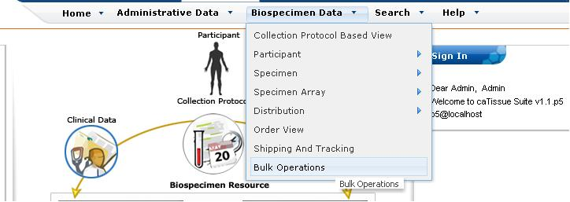

You can see the bulk operation added in the drop down on UI.

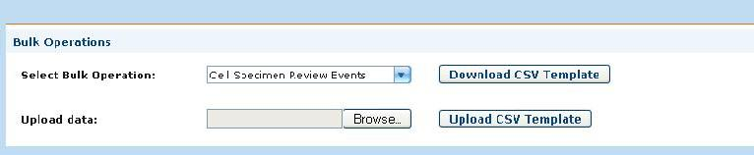

Now, select a bulk operation from the drop down menu and then click on the “Download CSV Template” button. A pop-up screen comes up which would ask the user to save the CSV file template.

After saving the template, open the CSV template and fill in the appropriate data in it and save the template.
Now click on the “Upload CSV Template” and upload the CSV template which has the data in it.

Now, the bulk operations’ processing starts and once the operations is successfully completed, a success message is shown and you can view the Output report file.

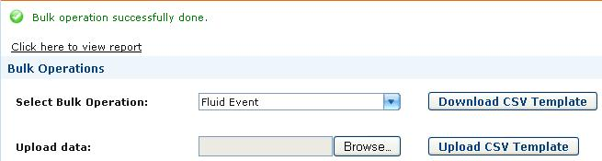

On clicking the view report tab, a pop-up window comes up asking to save the report file which is in CSV format.

